Bahria University,

Karachi Campus



Course: CSL 320 Operating systems Lab

Term: Spring 2022, Class: BSE- 4(B)

Submitted By:

Abdul Quddos 69984

(Name) (Reg. No.)

Submitted To:

Sir Rizwan Fazal/Engr. Rahemeen

Signed Remarks: Score:

INDEX

|  |  |  |  |  |
| --- | --- | --- | --- | --- |
| SNO | DATE | LAB NO | LAB OBJECTIVE | SIGN |
|  |  |  |  |  |
|  |  |  |  |  |
|  |  |  |  |  |
|  |  |  |  |  |
|  |  |  |  |  |
|  |  |  |  |  |
|  |  |  |  |  |
|  |  |  |  |  |
|  |  |  |  |  |
|  |  |  |  |  |
|  |  |  |  |  |
|  |  |  |  |  |
|  |  |  |  |  |
|  |  |  |  |  |
|  |  |  |  |  |
|  |  |  |  |  |
|  |  |  |  |  |
|  |  |  |  |  |

Bahria University,

Karachi Campus



LAB EXPERIMENT NO.

1

LIST OF TASKS

|  |  |
| --- | --- |
| TASK NO | OBJECTIVE |
| 1 | **Write a shell script to count all files and folders present in directory and stored the output into a text file and display its content on the terminal.** |
| 2 |  |
| 3 | **Write a shell script that either performs a file sort,file search or directory listing operation based on the user’s selection of the operation he/she would like to execute.** |
| 4 | **Write a C program that takes values of two matrices of size (𝑚×1) and (1×𝑛) as input from the user. Multiply the above two matrixes and store the resulting (𝑚×𝑛) matrix in a 2D array. Display the contents of the first and second matrices and also the resulting matrix. Achieve alignment in the displayed content as much possible.** |
|  |  |
|  |  |
|  |  |
|  |  |
|  |  |
|  |  |

Submitted On:

(Date: //)

**LAB # 01**

**Task # 01:**

**Write a shell script to count all files and folders present in directory and stored the output into a text file and display its content on the terminal.**

**Solution:**



**Output:**

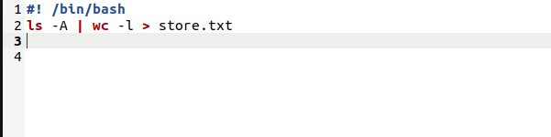

**Task #02:**

**Solution:**



**Output:**

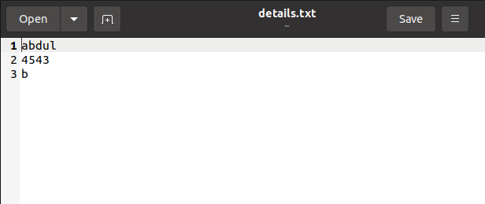

**Task #03:**

**Write a shell script that either performs a file sort,file search or directory listing operation based on the user’s selection of the operation he/she would like to execute.**

**Solution:**



**Output:**

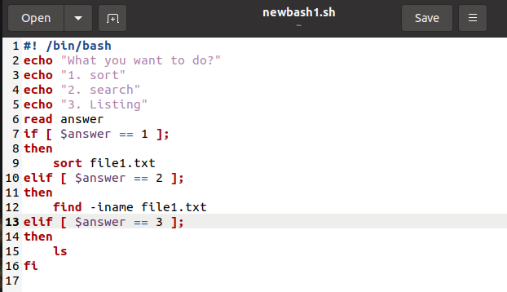

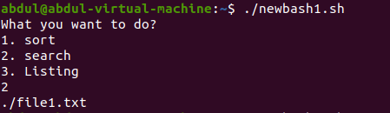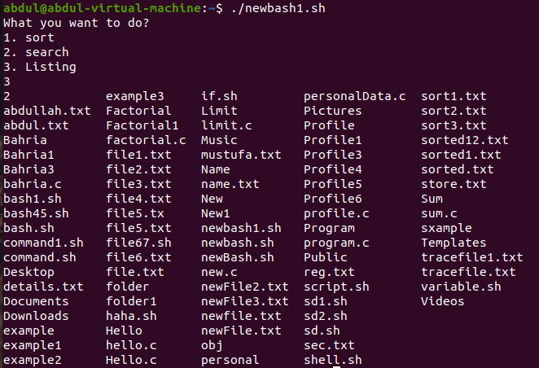 **Task4: Write a C program that takes values of two matrices of size (𝑚×1) and (1×𝑛) as input from the user. Multiply the above two matrixes and store the resulting (𝑚×𝑛) matrix in a 2D array. Display the contents of the first and second matrices and also the resulting matrix. Achieve alignment in the displayed content as much possible.**

**Code:**

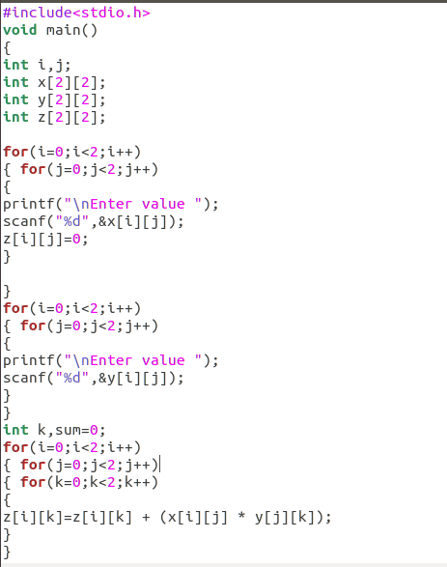

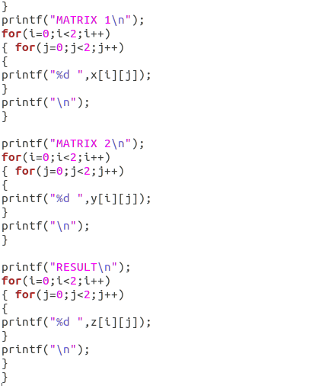

**Output:**

